YUVA INTERN • WEEK 4 TASK

MedCheck
Developing a Prototype
Wireframes, Screen Specifications & User Flow
Project | MedCheck – Medication Management App
Task Focus | Week 4 – Developing a Prototype
Deliverable | Interactive Mobile Application Prototype
Design | Usability • Simplicity • Easy Navigation • Functional Interaction

1. Tool used and the purpose of the prototype
Flutter with Dart was used to develop the MedCheck mobile application prototype. The purpose of the prototype is to transform the UI designs from Week 2 into an interactive application and demonstrate key features including medicine management, scheduling, reminders, medication history, refill tracking, safety information, and caregiver sharing.
2. Technology / Tools Used
Tools used to convert the UI designs from Week 2 into an interactive mobile application and demonstrate the backend architecture planned in Week 3.

2.1 Flutter
Flutter is used as the primary framework for developing the MedCheck mobile application prototype. It allows the different application screens to be created using a single codebase and supports interactive UI components.
Usage in MedCheck:
- Develop the mobile application interface
- Implement navigation between screens
- Create medicine cards, buttons, forms, and dashboard components
- Implement Add Medicine and Medicine Details workflows
- Build medication schedule, reminder, history, refill, safety, and caregiver screens
- Convert the Week 2 wireframes into an interactive prototype

2.2 Dart
Dart is the programming language used with Flutter. It handles the application logic and interactions between different screens.
Usage in MedCheck:
- Screen navigation
- Form validation
- Medicine data handling
- Schedule management
- Refill-status calculation
- Taken/skipped medication actions
- Application logic
Example:
User enters medicine
↓
Dart validates the input
↓
Medicine data is processed
↓
Medicine appears in the medicine list

2.3 Android Studio
Android Studio is used as the Android development environment and provides the Android SDK and emulator required for testing the MedCheck prototype.
Usage in MedCheck:
- Android SDK management
- Android emulator
- Running the Flutter application
- Testing different screen sizes
- Debugging application issues
- Building the Android prototype

2.4 Visual Studio Code
Visual Studio Code (VS Code) can be used as the primary code editor for writing and organizing the Flutter/Dart source code.
Usage in MedCheck:
- Writing Dart code
- Managing project files
- Installing Flutter/Dart extensions
- Debugging
- Running and testing the application

2.5 Firebase
Firebase can be integrated as the backend service for the MedCheck prototype.
The main Firebase services planned are:
Firebase Authentication
- User registration
- User login
- User authentication
- Logout
Cloud Firestore
- Store user information
- Store medicines
- Store medication schedules
- Store medication history
- Store reminders
- Store refill information
- Store caregiver-sharing permissions
The architecture is:
MedCheck Flutter App
↓
Firebase Authentication
↓
Cloud Firestore
↓
MedCheck Data

2.6 REST API
A REST API can be used as the communication layer between the mobile application, backend services, and external medicine-information services.
The API architecture planned for MedCheck includes:
API | Purpose
Authentication API | User authentication
Medicine API | Add, view, update medicines
Schedule API | Manage medication schedules
Reminder API | Manage reminders
History API | Record medication events
Refill API | Manage medicine quantities
Safety API | Retrieve medicine information
Sharing API | Manage caregiver permissions

Data can be exchanged using JSON over HTTPS.
Example:-
Flutter App
↓
REST API
↓
Backend
↓
Database

2.7 External Medicine Information API
An external medicine-information API can be used to demonstrate the Safety Information feature.
For the prototype, an appropriate drug-label information source such as openFDA can provide informational medicine/label data.

The workflow is:
User selects medicine
↓
Medcheck Backend
↓
Medicine Information API
↓
JSON Response
↓
Medcheck
↓
Safety Information Screen
The information should be presented as general informational content, not as a substitute for professional medical advice.

2.8 Postman
Postman can be used to test the REST API endpoints before connecting them to the Flutter application.
Example:
POST /medicines
↓
Send JSON request
↓
Backend
↓
JSON response
↓
Verify status
This helps demonstrate that the API architecture designed in Week 3 is working as intended.

2.9 Complete Technology Stack
You can include this table directly in your Week 4 DOCX:
Category | Technology / Tool | Purpose
Mobile Framework | Flutter | Build the mobile prototype
Programming Language | Dart | Application logic
Development IDE | VS Code | Write and manage source code
Android Development | Android Studio | SDK, emulator and testing
Authentication | Firebase Authentication | Secure user login
Database | Cloud Firestore | Store application data
API Architecture | REST API | Backend communication
Data Format | JSON | Exchange structured data
Communication | HTTPS | Secure data transmission
Medicine Information | External Medicine API | Retrieve informational drug data
API Testing | Postman | Test API requests/responses
Version Control | Git/GitHub | Track project development
"The following technologies were selected/planned for the MedCheck prototype."

3. Screenshots of Prototype
3.1 Splash Screen
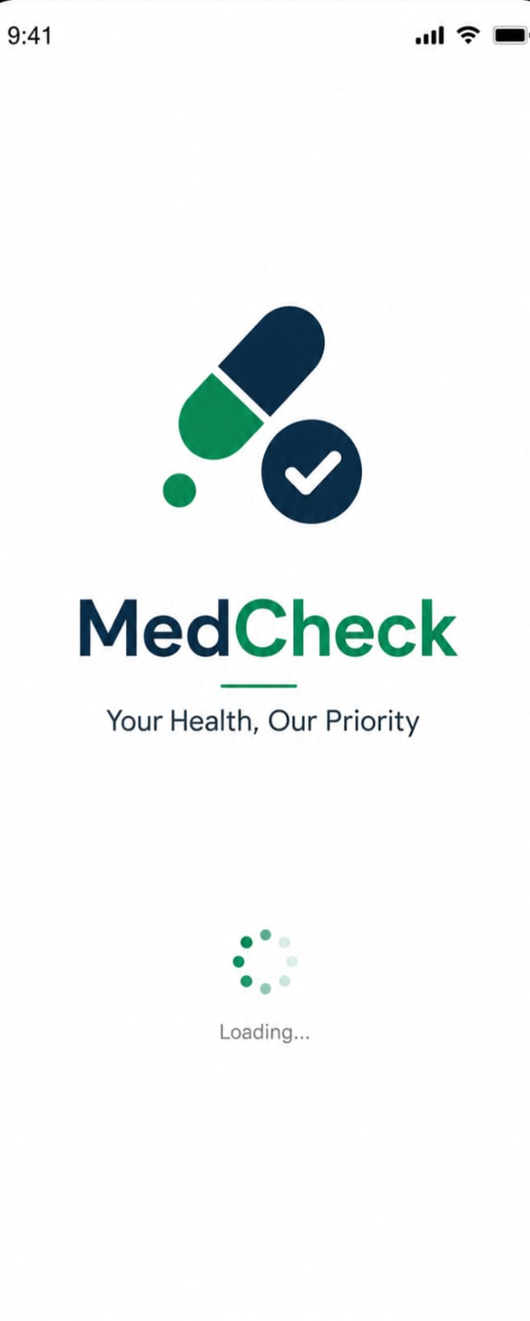

3.2 Login Screen

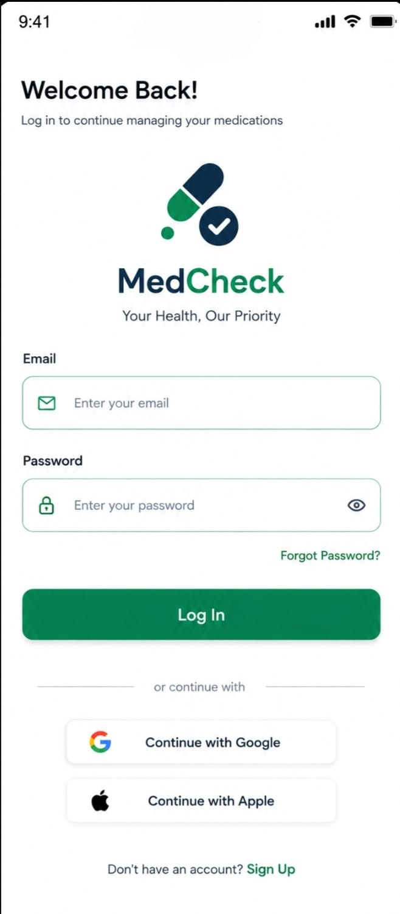

3.3 Home Dashboard
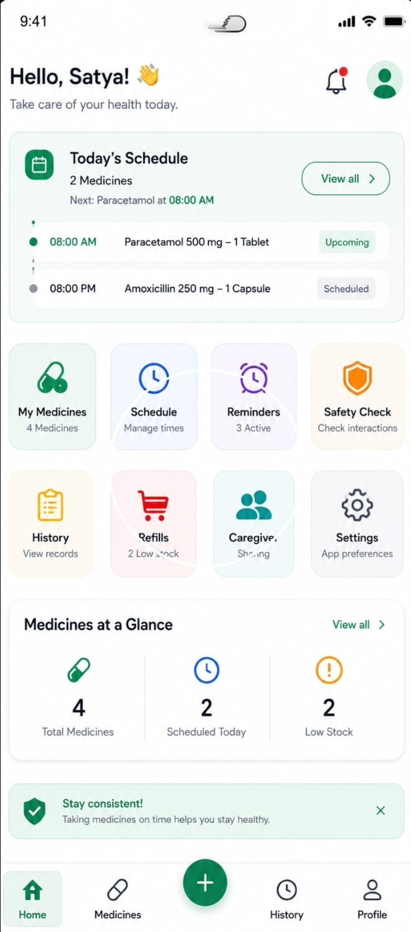

3.4 My Medicine Screen
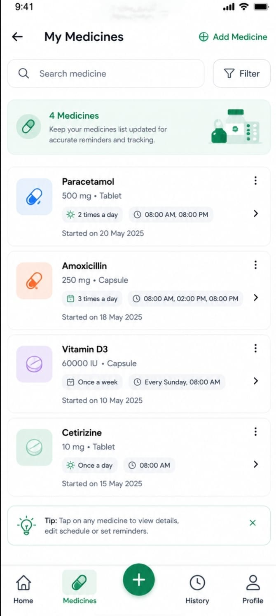

3.5 Add Medicine Screen
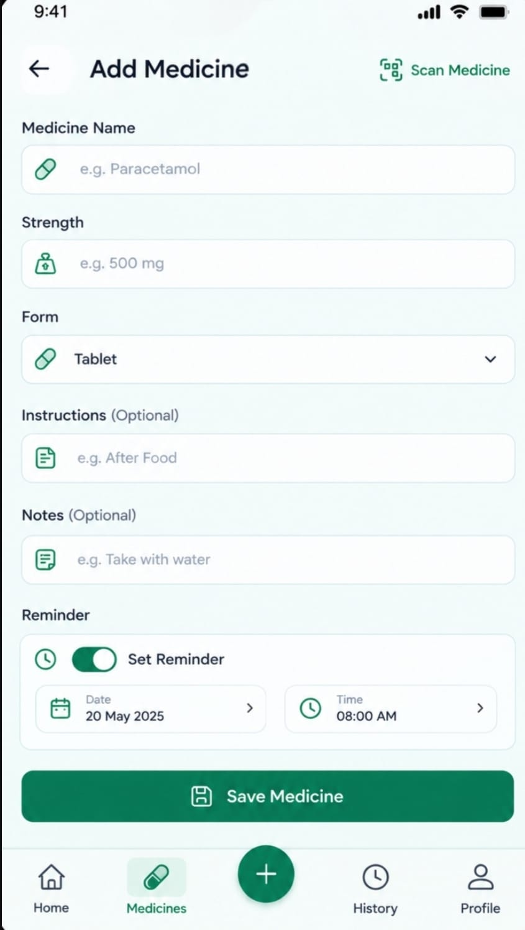

3.6 Medicine details
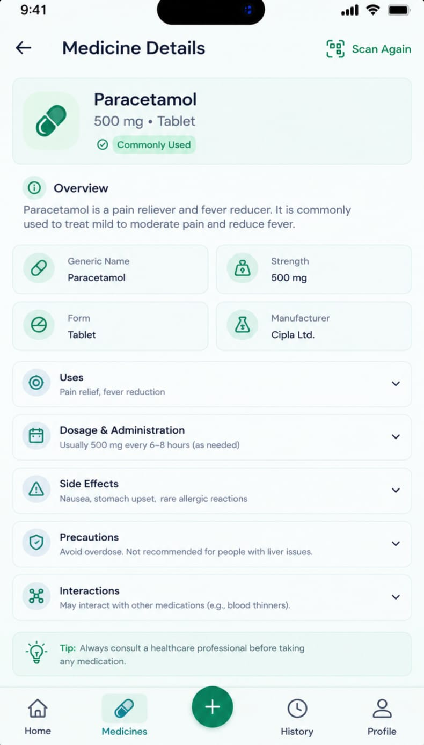

3.7 Medicine Schedule Screen
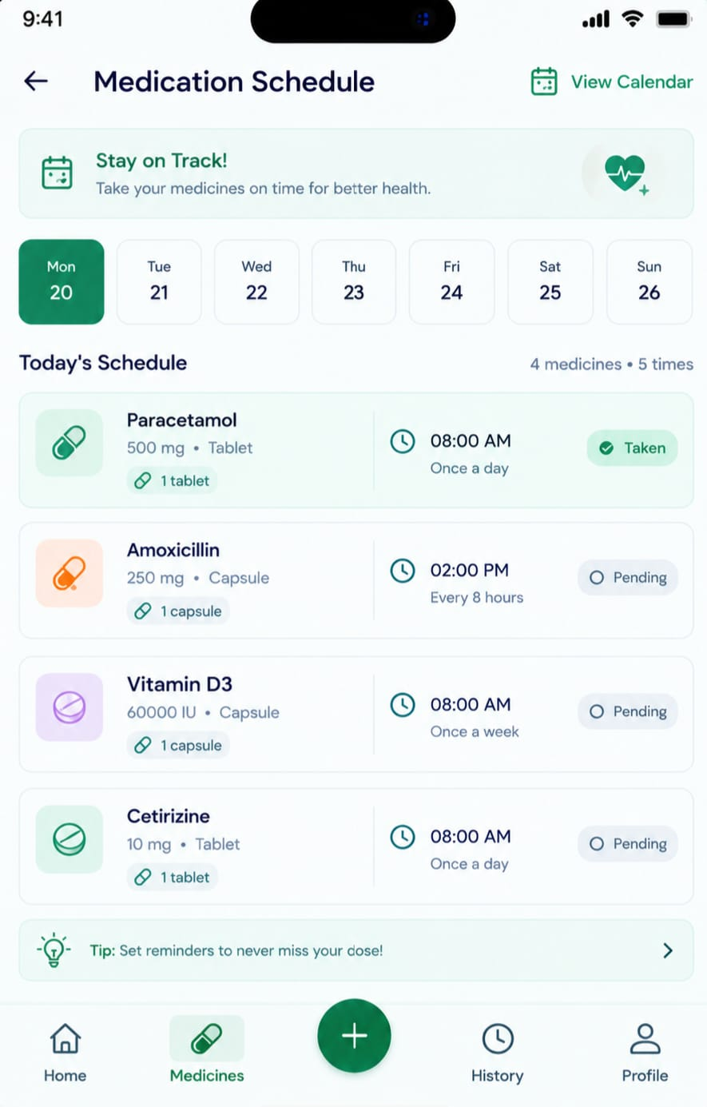

3.8 Reminders Screen
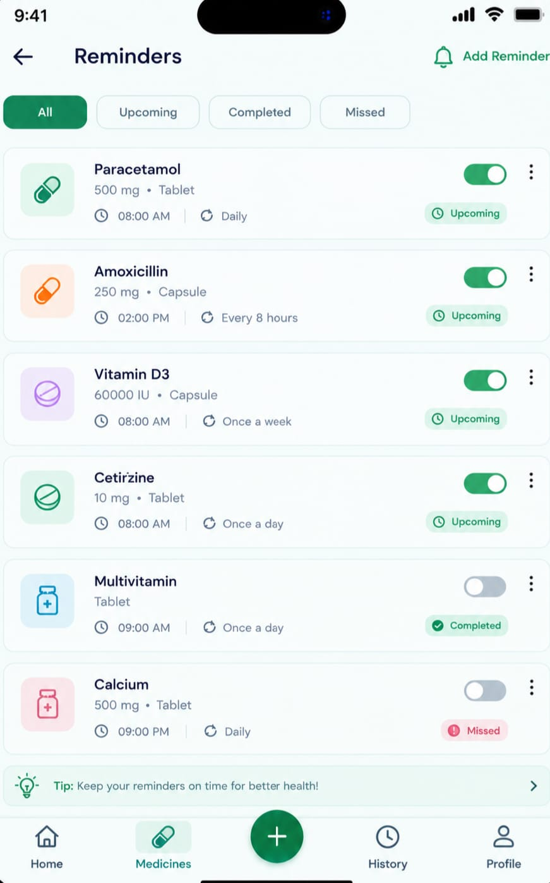

3.9 Medication History Screen
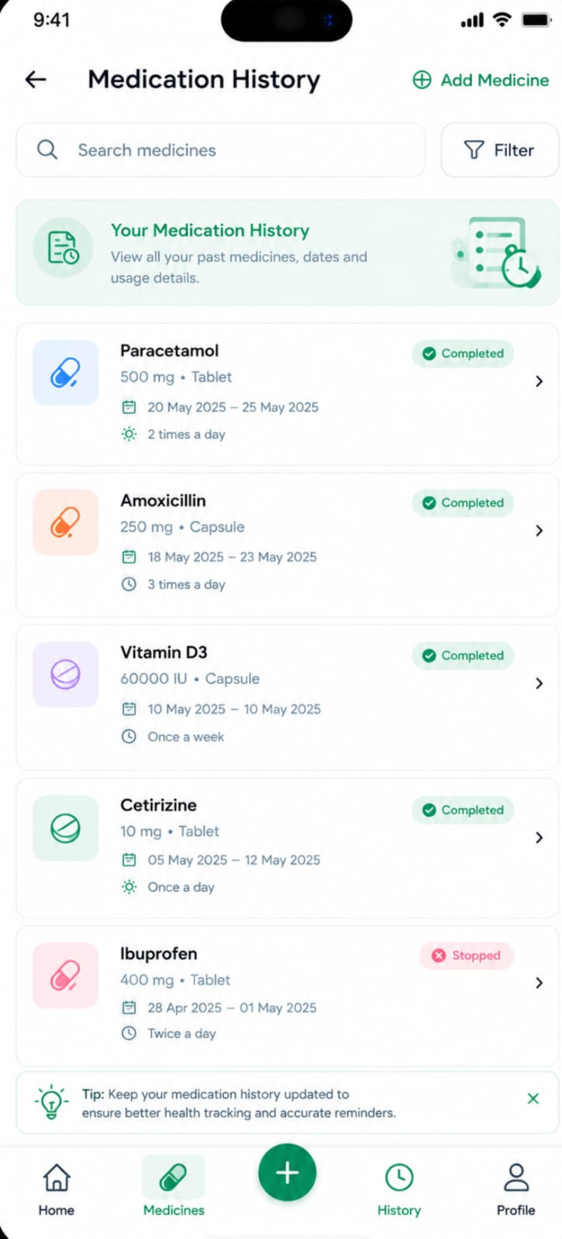

3.10 Refills Screen
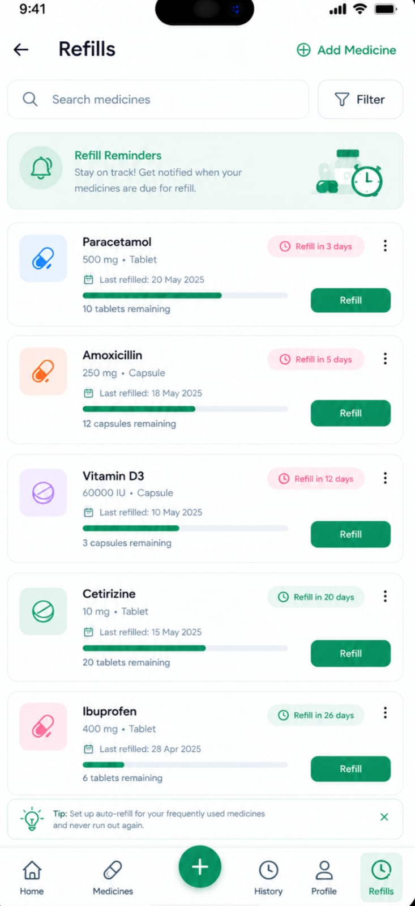

3.11 Safety Check Screen
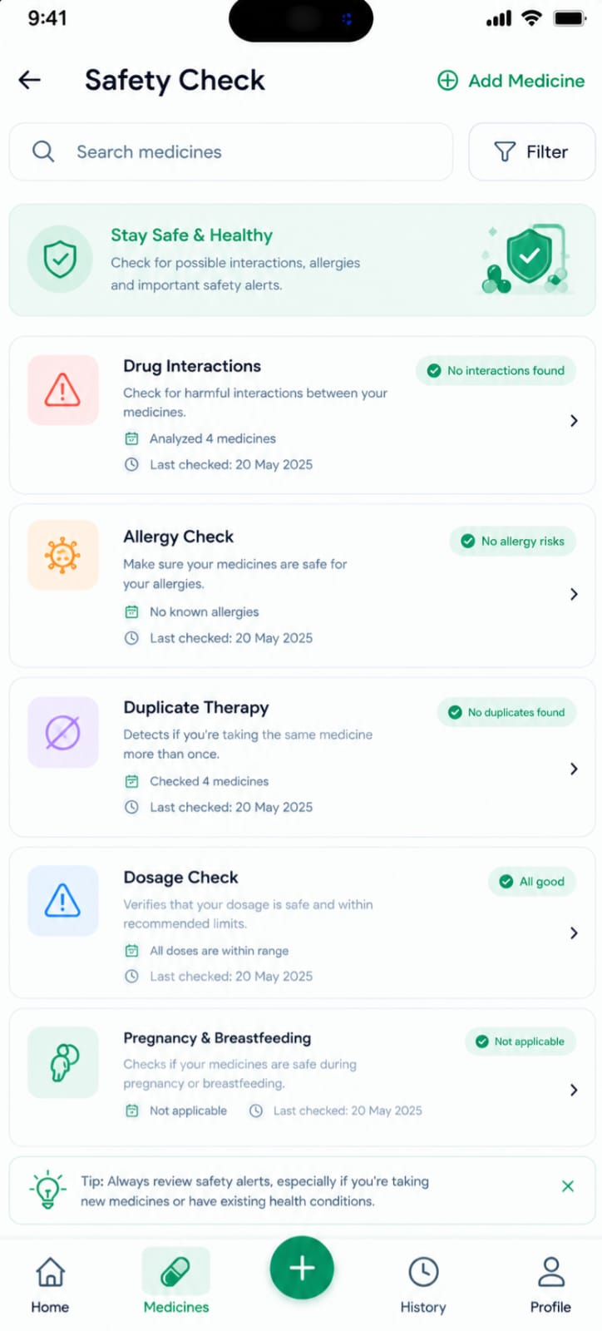

3.12 Care Giver Sharing Screen
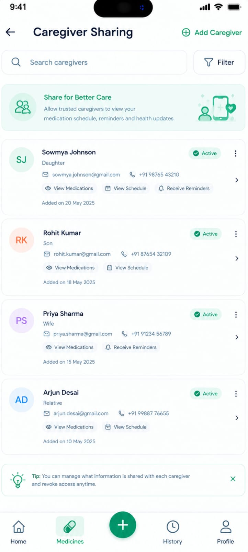

4. Screen-by-Screen Functionality
The MedCheck prototype consists of 12 interconnected screens designed to provide a simple and organized medication-management experience. The screens follow the UI structure developed in Week 2 and demonstrate the core functionality planned during Weeks 1–3

4.1 Splash Screen

Purpose
The Splash Screen provides the initial introduction to the MedCheck application. It displays the application name/logo and establishes the identity of the application before directing the user to the authentication area.

User Actions
- Launch the MedCheck application.
- Wait for the application to initialize.

Buttons / Interactions
- No major user interaction is required.
- The screen automatically transitions to the next screen.

What Happens After the Action
After a short loading period, the application checks the user's session and directs the user to the Login Screen or Home Dashboard.

Connection to Other Screens
Splash Screen
↓
Login Screen
↓
Home Dashboard

4.2 Login Screen

Purpose
The Login Screen allows registered users to securely access their MedCheck account.

User Actions
- Enter email address.
- Enter password.
- Select Login.
- Select Sign Up if they do not have an account.
- Use Forgot Password when necessary.

Buttons / Interactions
- Login – validates the entered credentials.
- Sign Up – opens the Registration interface.
- Forgot Password – initiates the password recovery process.

What Happens After the Action
After successful authentication, the user is taken to the Home Dashboard. Invalid credentials result in an appropriate error message.

Connection to Other Screens
Login
├── Sign Up → Registration
├── Forgot Password
└── Successful Login → Home Dashboard

4.3 Home Dashboard

Purpose
The Home Dashboard serves as the central screen of MedCheck. It provides a quick overview of the user's medication activities, upcoming schedules, reminders, and other important functions.

User Actions
The user can:
- View today's medication schedule.
- Open My Medicines.
- Check reminders.
- View medication history.
- Check refill status.
- Open the Safety Check feature.
- Access caregiver sharing through the relevant profile/settings area.

Buttons / Interactions
- My Medicines
- Reminders
- History
- Refills
- Safety Check
- Navigation controls

What Happens After the Action
Selecting an option opens the corresponding feature screen while keeping the user within the MedCheck workflow.

Connection to Other Screens
Home Dashboard
/ / | \ \
↓ ↓ ↓ ↓ ↓
Medicines Reminders History Refills Safety

4.4 My Medicines Screen

Purpose
The My Medicines screen provides a centralized list of medicines added by the user. It allows users to quickly review their active medications.

User Actions
- View medicines.
- Search for a medicine.
- Select a medicine to view details.
- Select Add Medicine to create a new record.

Buttons / Interactions
- Search – filters the medicine list.
- Add Medicine (+) – opens the Add Medicine screen.
- Medicine Card – opens Medicine Details.

What Happens After the Action
A newly saved medicine appears in the medicine list. Selecting an existing medicine opens its detailed information.

Connection to Other Screens
My Medicines
├── + Add Medicine → Add Medicine
│ ↓
│ Save Medicine
│ ↓
│ My Medicines
│
└── Select Medicine → Medicine Details

4.5 Add Medicine Screen

Purpose
The Add Medicine screen allows users to enter and save information about a medicine they need to manage.

User Actions
The user can enter:
- Medicine name
- Strength
- Form
- Instructions
- Notes or additional information

Buttons / Interactions
- Save Medicine – validates and stores the medicine information.
- Back – returns to the previous screen without saving.

What Happens After the Action
After successful validation, the medicine is saved and becomes visible on the My Medicines screen.

Connection to Other Screens
My Medicines
↓
Add Medicine
↓
Enter Information
↓
Save
↓
My Medicines
↓
Medicine Details

4.6 Medicine Details Screen

Purpose
The Medicine Details screen displays complete information about a selected medicine and provides access to related medication-management functions.

User Actions
The user can:
- Review medicine information.
- Edit medicine details.
- Create or modify a medication schedule.
- Access refill information.
- Deactivate a medicine where applicable.

Buttons / Interactions
- Edit Medicine
- Schedule
- Refill
- Back

What Happens After the Action
Selecting Schedule opens the Medication Schedule screen. Selecting Refill opens the Refills screen. Editing updates the stored medicine information.

Connection to Other Screens
My Medicines
↓
Medicine Details
├── Edit
├── Schedule → Medication Schedule
└── Refill → Refills

4.7 Medication Schedule Screen

Purpose
The Medication Schedule screen allows users to define when and how frequently a medicine should be taken.

User Actions
The user can specify:
- Medicine
- Frequency
- Medication time
- Start date
- End date, if applicable
- Schedule status

Buttons / Interactions
- Save Schedule – stores the medication schedule.
- Time Selector – selects the medication time.
- Frequency Selector – selects daily, weekly, or another supported frequency.
- Back – returns to the previous screen.

What Happens After the Action
After saving, the schedule becomes associated with the selected medicine and can be used by the reminder workflow.

Connection to Other Screens
Medicine Details
↓
Medication Schedule
↓
Save Schedule
↓
Reminders
↓
Medication History

4.8 Reminders Screen

Purpose
The Reminders screen helps users view and manage notifications associated with their medication schedules.

User Actions
The user can:
- View upcoming medication reminders.
- Enable or disable reminders.
- Review the medicine and scheduled time.
- Add or modify reminder settings where supported.

Buttons / Interactions
- Reminder Toggle – enables or disables a reminder.
- Add Reminder – creates a new reminder.
- Reminder Item – opens or displays its associated schedule.

What Happens After the Action
Enabled reminders are associated with the medication schedule. When a medication event is completed, the user can record the outcome, which contributes to the medication history.

Connection to Other Screens
Medication Schedule
↓
Reminders
↓
Medication Event
├── Taken
└── Skipped
↓
Medication History

4.9 Medication History Screen

Purpose
The Medication History screen maintains a record of medication events, helping users review previously recorded medication activity.

User Actions
The user can:
- View previous medication events.
- Check whether a scheduled medicine was marked as taken or skipped.
- Review medication activity by date.

Buttons / Interactions
- History Items – display individual medication events.
- Date/Filter Controls – help organize historical records where implemented.

What Happens After the Action
The screen retrieves and displays recorded medication events in chronological order.

Connection to Other Screens
Reminders
↓
Medication Action
↓
Taken / Skipped
↓
Medication History

4.10 Refills Screen

Purpose
The Refills screen allows users to monitor the remaining quantity of their medicines and identify medicines that may require replenishment.

User Actions
The user can:
- View current medicine quantity.
- Set or review a refill threshold.
- Update the remaining quantity.
- Monitor low-stock medicines.

Buttons / Interactions
- Update Quantity – changes the available quantity.
- Refill Information – displays refill-related details.
- Low Stock Indicator – highlights medicines that have reached the defined threshold.

What Happens After the Action
For example, if the available quantity is 4 and the refill threshold is 5, the application displays a Low Stock status.
Quantity = 4
Threshold = 5
↓
4 ≤ 5
↓
Low Stock

Connection to Other Screens
Medicine Details
↓
Refills
↓
Update Quantity
↓
Low Stock Status

4.11 Safety Check Screen

Purpose
The Safety Check screen provides access to informational medicine and safety-related information associated with selected medicines.

User Actions
The user can:
- Select a medicine.
- Request available medicine information.
- Review the returned information.

Buttons / Interactions
- Medicine Selector – selects the medicine to review.
- Check Information – requests available medicine information.
- Back – returns to the previous screen.

What Happens After the Action
The application can send the selected medicine information to the backend/external medicine-information service and display the returned information.

Connection to Other Screens
Medicine Details
↓
Safety Check
↓
Backend / Medicine Information API
↓
Information Response
↓
Safety Information

4.12 Caregiver Sharing Screen

Purpose
The Caregiver Sharing screen provides a controlled method for the user to share selected medication information with an authorized caregiver.

User Actions
The user can:
- Enter/select a caregiver.
- Choose which information can be shared.
- Grant or modify sharing permissions.
- Revoke sharing access where implemented.

Buttons / Interactions
- Caregiver Selection/Input – identifies the intended caregiver.
- Permission Controls – select information such as medicines, schedules, history, or refills.
- Share Access – saves the selected permissions.

What Happens After the Action
The selected sharing permissions are stored and determine what information the caregiver is permitted to access.

Connection to Other Screens
Profile
↓
Caregiver Sharing
↓
Select Caregiver
↓
Select Permissions
↓
Share Access
↓
Authorized Information

4.13 Complete Screen Interaction Flow
The 12 screens work together as one continuous application:
SPLASH
│
▼
LOGIN
│
▼
HOME DASHBOARD
/ / | \ \
/ / | \ \
▼ ▼ ▼ ▼ ▼
MY MEDS REMINDERS HISTORY REFILLS SAFETY
│ │
▼ ▼
ADD MEDICINE SCHEDULE
│ │
▼ ▼
MEDICINE DETAILS
│
┌────┼──────────┐
▼ ▼ ▼
SCHEDULE REFILLS SAFETY
PROFILE
│
▼
CAREGIVER SHARING

Overall Prototype Interaction
The primary workflow is:
Login → Home Dashboard → My Medicines → Add Medicine → Medicine Details → Medication Schedule → Reminders → Taken/Skipped → Medication History
Additional workflows allow the user to monitor refills, review medicine information, and manage caregiver sharing.
This screen-by-screen implementation demonstrates how the Week 2 UI design was transformed into an interactive Week 4 prototype, while the relationships planned in Week 3's database and API architecture provide the underlying structure for storing and exchanging the application's data.

5. Prototype Navigation Flow
Welcome
↓
Login / Register
↓
Home Dashboard
├── My Medicines → Add/Edit Medicine
├── Schedule → Reminder
├── History
├── Refills
├── Safety Check
└── Profile → Caregiver Sharing

6. Week 2 → Week 4 Implementation

The Week 2 wireframes served as the visual and functional blueprint for the MedCheck prototype developed in Week 4. The wireframes were converted into interactive application screens while maintaining the planned layout, navigation structure, usability principles, and core medication-management workflows.

Wireframe-to-Prototype Process

Week 2 Wireframes
↓
Screen Structure & Navigation
↓
Flutter UI Development
↓
Interactive Components
↓
Backend/Data Integration
↓
Week 4 MedCheck Prototype

SCREEN IMPLEMENTATION:

Week 2 Wireframe | Week 4 Prototype Implementation
Splash Screen | Implemented as the application's initial screen
Login Screen | Converted into an interactive authentication interface
Home Dashboard | Implemented with medication summaries and navigation options
My Medicines | Converted into a medicine-list interface
Add Medicine | Implemented with input fields and save functionality
Medicine Details | Displays information for the selected medicine
Medication Schedule | Provides frequency and time selection
Reminders | Displays scheduled medication reminders
Medication History | Displays taken/skipped medication records
Refills | Displays quantity and low-stock status
Safety Check | Provides access to medicine-information functionality
Caregiver Sharing | Provides permission-based sharing controls

Navigation Implementation
The navigation designed in Week 2 was converted into an interactive flow in Week 4. For example:
Home Dashboard
↓
My Medicines
↓
Add Medicine
↓
Save Medicine
↓
My Medicines
↓
Medicine Details
↓
Medication Schedule
↓
Reminders
↓
Medication History
This ensures that users can move logically between related features without unnecessary steps.

Interactive Elements
Static wireframe components were converted into functional interface elements, including:
- Buttons for navigation and actions
- Text fields for medicine information
- Dropdown/select controls for medicine form and frequency
- Time and date selectors for schedules
- Toggle controls for reminders
- Action buttons for Taken and Skipped
- Quantity controls for refill tracking
- Permission controls for caregiver sharing

Week 2 Design Principles Maintained
The prototype retained the major design principles established during Week 2:
- Simplicity: Only relevant information is displayed on each screen.
- Easy Navigation: Related features are accessible through consistent navigation.
- Consistency: Similar buttons, cards, labels, and layouts are used throughout the application.
- Usability: Important actions such as adding a medicine and viewing today's schedule are easily accessible.
- Clear Information: Medicine names, schedules, reminders, history, and refill status are presented in an organized manner.

Example of Conversion
For e Week 2
Add Medicine Wireframe
↓
Medicine Name
Strength
Form
Instructions
↓
Save Medicine xample, the Week 2 Add Medicine wireframe defined the required fields and action:
In Week 4, these elements were implemented as interactive Flutter widgets. When the user enters the information and selects Save Medicine, the application validates the input and can store the medicine data through the planned backend/database architecture.

Integration with Week 3
The Week 4 prototype also connects the UI concept with the technical architecture designed in Week 3:
Week 2 UI
↓
Flutter Prototype
↓
API / Backend
↓
Database

For example:
Add Medicine → Medicine API → Database → My Medicines
Similarly:
Schedule → Reminder → Medication Action → History
This demonstrates that Week 4 is not a separate design exercise; it is the implementation stage that connects the Week 2 user interface design with the Week 3 database and API architecture.
Overall, the Week 2 wireframes were transformed into an interactive MedCheck prototype by implementing the planned screens, navigation paths, input controls, buttons, and medication-management workflows in Flutter. This conversion allows the proposed user experience to be demonstrated and evaluated before progressing toward a complete production application.

7. Week 3 → Week 4 Integration
The Week 3 database and API architecture was used as the technical foundation for the Week 4 MedCheck prototype. The prototype represents how user actions and application data would interact with the planned backend, even where some components are simulated rather than connected to a live production server.

7.1 Integration Architecture
The planned Week 3 architecture is represented in the Week 4 prototype as follows:
┌──────────────────────────┐
│ MedCheck Prototype │
│ Flutter UI │
└────────────┬─────────────┘
│
│ API Requests
▼
┌──────────────────────────┐
│ REST API / Backend │
└────────────┬─────────────┘
│
┌─────┴─────┐
▼ ▼
┌────────────┐ ┌────────────────────┐
│ Firestore/ │ │ Medicine Information│
│ Database │ │ API │
└────────────┘ └────────────────────┘
The Week 4 prototype focuses primarily on demonstrating the front-end workflows, while the Week 3 architecture defines how these workflows would communicate with backend services.

7.2 Database Representation in the Prototype
The database tables/collections planned in Week 3 correspond directly to the prototype screens.
Week 3 Database | Week 4 Prototype Screen | Example Data
User | Login/Profile | Name, email
Medicine | My Medicines | Medicine name, strength, form
Medication Schedule | Medication Schedule | Frequency, time, start date
Medication History | Medication History | Taken, skipped, date/time
Reminder | Reminders | Medicine, reminder time, status
Refill | Refills | Quantity, threshold, status
Safety Records | Safety Check | Medicine, information source
Sharing Permissions | Caregiver Sharing | Caregiver, permissions
This demonstrates that each major prototype feature has a corresponding data structure defined in Week 3.

7.3 Medicine Management Integration
The Add Medicine screen represents the Medicine API and Medicine database planned in Week 3.

Workflow
User enters medicine details
↓
Save Medicine
↓
Medicine API
↓
Medicine Database
↓
My Medicines
For example:
Medicine Name: Paracetamol
Strength: 500 mg
Form: Tablet

The prototype displays the entered medicine in the My Medicines screen. In a fully connected implementation, this information would be sent to the backend and stored in the Medicine collection.

7.4 Medication Schedule Integration
The Medication Schedule screen represents the Schedule API and database relationship.

Medicine
↓
Create Schedule
↓
Schedule API
↓
Schedule Database
↓
Reminder
Example:
Medicine: Example Medicine
Frequency: Daily
Time: 08:00 AM
The schedule is associated with the selected medicine through the planned medicineId relationship.

7.5 Reminder Integration
The Reminder screen represents the Week 3 Reminder database and API.
Medication Schedule
↓
Reminder
↓
Reminder Time
↓
Medication Action
For example, an 08:00 AM schedule can generate an associated reminder record containing:
userId
medicineId
scheduleId
time
enabled
The Week 4 prototype visually represents this relationship through reminder cards and enable/disable controls.

7.6 Medication History Integration
When the user selects Taken or Skipped, the action represents a Medication History API request.

Reminder
↓
User selects "Taken"
↓
History API
↓
Medication History
↓
History Screen
Example record:
Medicine: Example Medicine
Status: Taken
Date: 08/09/2026
Time: 08:00 AM
In a live implementation, this information would be stored in the Medication History collection.

7.7 Refill Integration
The Refills screen represents the Refill API and Refill database.
Example:
Current Quantity = 4
Threshold = 5
The prototype applies the planned logic:
Quantity ≤ Threshold
↓
Low Stock
The resulting status is displayed to the user.
In a connected implementation, quantity changes would be sent through the Refill API and stored in the database.

7.8 Safety API Integration
The Safety Check screen represents the external medicine-information API planned in Week 3.
User selects medicine
↓
MedCheck Backend
↓
External Medicine Information API
↓
JSON Response
↓
Safety Check Screen
The prototype can demonstrate this workflow using sample/mock response data if the live API has not yet been connected.
The purpose is to demonstrate where the external API fits into the MedCheck architecture.

7.9 Caregiver Sharing Integration
The Caregiver Sharing screen represents the Sharing Permissions database structure.
Example:
Owner
↓
Caregiver
↓
Permissions
├── Medicines
├── Schedule
├── History
└── Refills
In a complete implementation, these permissions would be stored in the sharingPermissions collection and used by the backend to determine which information the caregiver can access.

7.10 API Request and Response Representation
The Week 4 prototype can demonstrate the planned API structure using sample JSON.

Example: Add Medicine Request
{
"userId": "USER001",
"name": "Example Medicine",
"strength": "500 mg",
"form": "Tablet",
"instructions": "As directed"
}

Example Response
{
"success": true,
"medicineId": "MED001",
"message": "Medicine added successfully"
}
This represents the planned communication between the Flutter interface and the backend.

7.11 Prototype vs Live Backend
It is important to clearly distinguish between demonstrated prototype functionality and planned backend integration.
Component | Week 4 Representation
UI screens | Implemented
Screen navigation | Implemented
Forms | Implemented
Medicine workflow | Demonstrated
Schedule workflow | Demonstrated
Reminder workflow | Demonstrated
History workflow | Demonstrated
Refill logic | Demonstrated
Database architecture | Represented/planned
REST API structure | Represented/planned
External medicine API | Demonstrated or simulated
Production authentication | Planned/implemented depending on actual setup
"The Week 4 prototype represents the database and API architecture planned during Week 3. Core user interactions and data flows are demonstrated through the prototype, while backend operations and external API responses may be simulated where a live connection has not yet been implemented. This approach validates the intended integration between the user interface, backend services, database, and external medicine-information services."

7.12 Overall Week 3 → Week 4 Flow
WEEK 4 PROTOTYPE
│
▼
Flutter UI
│
┌───────────────┼────────────────┐
▼ ▼ ▼
Medicines Schedule Reminders
│ │ │
▼ ▼ ▼
Medicine DB Schedule DB Reminder DB
│ │
└───────────────┬────────────────┘
▼
Medication History
│
▼
History DB

Safety Check ──→ External API

Refills ───────→ Refill DB

Caregiver ─────→ Sharing Permissions

The Week 3 database schema and API architecture provide the technical foundation, while the Week 4 prototype provides a visual and interactive demonstration of those planned components. Together, they show how MedCheck can progress from a UI concept into a structured application with defined data storage, API communication, medication workflows, and controlled information sharing.

8. Key Functionality Demonstrated
The Week 4 MedCheck prototype demonstrates the main medication-management workflows planned during Weeks 2 and 3. Each function is connected to the corresponding UI screen and planned database/API structure.
No. | Functionality | Prototype Demonstration | Related Backend/Data
1 | Adding a Medicine | User enters medicine name, strength, form, instructions, and saves it to the medicine list. | Medicine API → Medicine collection
2 | Creating a Schedule | User selects a medicine, frequency, time, and schedule dates. | Medication Schedule API → Schedule collection
3 | Setting a Reminder | User creates/enables a reminder based on the medication schedule. | Reminder API → Reminder collection
4 | Marking Medication as Taken/Skipped | User records the medication status using the available action controls. | Medication History API → History collection
5 | Viewing Medication History | User views previously recorded medication activities in chronological order. | Medication History collection
6 | Checking Refill Status | User views available quantity and refill threshold. Low-stock status is displayed when applicable. | Refill API → Refill collection
7 | Accessing Safety Information | User selects a medicine and views available medicine-related safety information. | Backend → External medicine-information API
8 | Managing Caregiver Permissions | User selects a caregiver and controls which information can be shared. | Sharing Permissions → Database

8.1 Key User Workflow
A complete example of the prototype flow is:
Add Medicine
↓
Create Schedule
↓
Set Reminder
↓
Medication Reminder
↓
Taken / Skipped
↓
Medication History
↓
Check Refill Status

Example
A user adds Example Medicine – 500 mg, creates a daily schedule, and sets a reminder. When the reminder is displayed, the user can record the medication status. That action is represented in the Medication History screen, while the Refills screen displays the available quantity and refill status.

8.2 Safety Information
The Safety Check feature demonstrates where medicine-information data would be retrieved through the planned external API. If the live API is not connected in the prototype, sample/mock data can be used to demonstrate the interface and data flow.
Note: The Safety Check feature is intended to demonstrate access to medicine information and is not presented as a substitute for professional medical advice or a clinical interaction checker.

8.3 Prototype Validation
These functionalities demonstrate that the Week 4 prototype is not limited to static screens. The screens are connected through user actions and represent the planned data flow between the Flutter interface, APIs, database, and external medicine-information service.

9. Prototype Limitations
The Week 4 MedCheck prototype is primarily designed to demonstrate the application's UI, navigation, workflows, and planned system integration. Since it is a prototype, some backend-dependent functions may be simulated rather than connected to live services.
Functionality | Status | Description
Splash Screen | Functional | Displays the application introduction and transitions to the next screen.
Login / Registration UI | Prototype | User interface and navigation are demonstrated; live authentication may not be connected.
Adding a Medicine | Functional in prototype | User can enter medicine details and view the added medicine in the prototype.
Medicine Details | Functional in prototype | Displays the selected medicine's stored/displayed information.
Creating a Schedule | Functional in prototype | User can select frequency and time and save the schedule within the prototype flow.
Setting Reminders | Simulated | Reminder interface and controls are demonstrated; actual background/push notifications may not be implemented.
Taken / Skipped Status | Functional in prototype | User can select a medication status and see it represented in the prototype.
Medication History | Prototype/Simulated | History entries can be demonstrated, but persistent backend storage may not be connected.
Refill Status | Functional in prototype | Quantity and threshold logic can be demonstrated, including a Low Stock status.
Safety Information | Simulated | The Safety Check interface and API flow are demonstrated; external medicine-information responses may use sample/mock data.
Caregiver Permissions | Prototype | Permission controls and sharing workflow are demonstrated; real multi-user access control may not be connected.
Firebase / Database | Planned/Partial | Database structure is defined according to Week 3, but live persistence depends on the implementation stage.
REST APIs | Planned/Simulated | API endpoints and request/response formats are represented; not all APIs may be connected to a live backend.

9.1 Main Limitations
- Live backend integration may be incomplete: Some prototype data may be stored temporarily or locally rather than in a production database.
- Authentication: The login and registration screens demonstrate the intended workflow, but full Firebase Authentication integration may not yet be implemented.
- Notifications: Reminder screens demonstrate reminder management, while actual scheduled push notifications may be simulated.
- External API: Safety information may use mock/sample responses until the external medicine-information API is connected.
- Caregiver sharing: The permission interface demonstrates the intended access-control model, but real multi-user sharing requires backend authorization.
- Production security: The prototype demonstrates the planned security architecture but is not a production-ready medical application.

9.2 Report-Ready Summary
The MedCheck Week 4 prototype successfully demonstrates the major application screens, navigation, medicine management, scheduling, medication status, refill logic, and planned API/database workflows. Backend-dependent features such as live authentication, persistent database storage, push notifications, external safety-information retrieval, and multi-user caregiver access may remain simulated or partially implemented. These limitations are expected at the prototype stage and identify the areas for future development.

10 Feedback
Testing of the prototype focused on navigation clarity, ease of use, screen consistency, and completion of the main workflows. The prototype structure makes the major functions accessible from the Home Dashboard and keeps related actions connected between screens.
Based on the prototype review, the following improvements were identified for future development:
- Connect all prototype screens to a live backend and database.
- Implement actual scheduled notifications.
- Complete live external medicine-information API integration.
- Implement secure multi-user caregiver access.
- Add stronger form validation and error handling.
- Conduct testing with a larger group of users after backend integration.

